To parin,

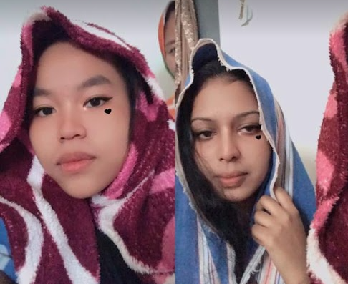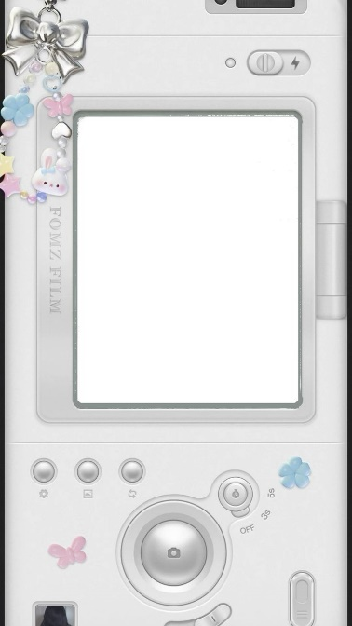Let’s me start off by praising myself because unlike u I am born amazing, very demure very mindful very cool very wow extra cheese lagi best Honestly, you should write a lengthy essay thanking my parents for bringing someone as extraordinary as me into the world. True rt? Oky enough of u shower me with love 💕. Parin, if someone has to give thanks. It’s me Masita Mara writing long ass essay to thank my uncle suraj and aunty anusha for fallin in love and bringing you, my bestie, into the world. I'm so grateful you were born. We didn’t meet on the first day of school, but our paths crossed, and eventually, we became the best of friends.

We've shared so many laughs, secrets, and adventures, and I wouldn’t trade our friendship for anything.

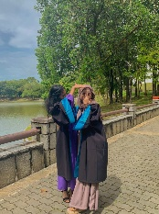Omg frrr like I swear to god the moment we spent together is super priceless like I would rather be a beggar than selling my memories with you. But now, with you in Malaysia and me in Cambodia, it’s a bit like having that piece of my heart far away. I miss our random hangouts, the late-night talks, and just being able to see you whenever I want. It’s not the same without you here, and I can’t wait until the day we’re together again, causing our usual mischief and making more memories.

Until then, know that no matter the distance, you’re always in my heart, bb girl. 💕 I will always root for you. Standing behind you. You have all our that cool class behind you. I love you.

Sincerely,

Your Masi